**Exercise 1 - Dawson**

import java.awt.*;

public class DrawShapesAndText

{

public static void main(String[] args)

{

DrawingPanel panel = new DrawingPanel(300, 300);

int x = 50;

int y = 220;

panel.setBackground(Color.DARK_GRAY);

Graphics2D g = panel.getGraphics();

g.drawRect(150, 10, 40, 20);

g.setColor(Color.RED);

g.setStroke(new BasicStroke(20));

g.drawOval(110, 25, 30, 50);

g.fillOval(150, 50, 60, 30);

g.setColor(new Color(200,100,0));

g.fillRect(209, 220, 40, 50);

g.fillRect(x, y, 40, 50);

g.setColor(new Color(255,216,0));

g.fillRect(x+20, y+10, 10, 20);

g.setColor(Color.BLUE);

g.setFont(new Font("SansSerif", Font.PLAIN, 18));

g.drawString("Shapes and Colors", 80, 130);

}

}

**Output**

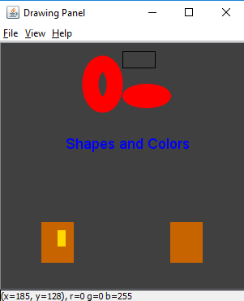

**Exercise 2 - Dawson**

import java.awt.*;

import java.util.concurrent.ThreadLocalRandom;

public class StepPyramid {

public static void main(String[] args)

{

DrawingPanel panel = new DrawingPanel(300, 300);

panel.setBackground(Color.WHITE);

Graphics2D g = panel.getGraphics();

g.setColor(new Color(200,100,0));

//set top blocks

for(int l = 100; l < 200; l+=50) {

g.setColor(new Color(randInt(),randInt(),randInt()));

g.fillRect(l, 150, 50, 50);

//Set middle blocks

for(int j = 50; j < 250; j+= 50) {

g.setColor(new Color(randInt(),randInt(),randInt()));

g.fillRect(j, 200, 50, 50);

//Set Base Blocks

for(int i = 0; i < 300; i+=50) {

g.setColor(new Color(randInt(),randInt(),randInt()));

g.fillRect(i, 250, 50, 50);

}

}

}

g.setColor(new Color(randInt(),randInt(),randInt()));

g.fillRect(125, 100, 50, 50);

}

//Created a function to Condense code by not having to repeatedly type ThreadLocal

public static int randInt() {

return ThreadLocalRandom.current().nextInt(100,255);

}

}

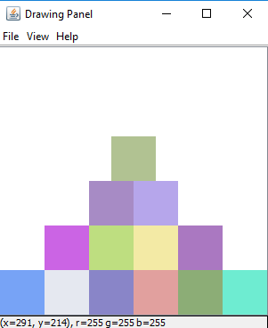

**Exercise 3 - Dawson**

import java.awt.*;

public class Exercise3 {

public static void main(String[] args)

{

DrawingPanel panel = new DrawingPanel(300, 300);

panel.setBackground(Color.WHITE);

Graphics2D g = panel.getGraphics();

g.setColor(new Color(255,0,0));

g.fillOval(75, 250, 150, 50);

g.fillOval(100, 225, 100, 25);

g.fillOval(125, 175, 50, 50);

}

}

**Output**

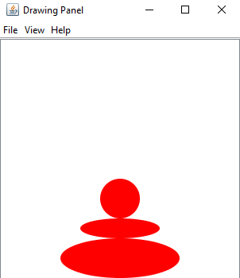

**Exercise 4 - Dawson**

import java.awt.Color;

import java.awt.Graphics2D;

public class Exercise4 {

public static void main(String[] args)

{

int x,y,wX,hY, color;

x = 5;

y = 5;

wX = 300;

hY = 300;

color = 255;

DrawingPanel panel = new DrawingPanel(300, 300);

panel.setBackground(Color.WHITE);

Graphics2D g = panel.getGraphics();

for(int i = 0; i < 5; i++) {

g.setColor(new Color(color-=50,0,0));

g.fillOval(x+=25, y += 25, wX -= 50, hY -= 50);

g.setColor(Color.BLACK);

g.drawOval(x, y, wX, hY);

}

}

}

**Output**

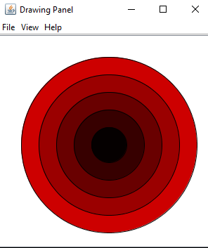

**Exercise 5**

import java.awt.Color;

import java.awt.Graphics2D;

public class Exercise5 {

public static void main(String[] args) {

int busX = -101;

DrawingPanel panel = new DrawingPanel(600, 156);

panel.setBackground(Color.WHITE);

Graphics2D g = panel.getGraphics();

while(busX<600) {

//Bus Body

g.setColor(Color.YELLOW);

g.fillRect(2 + busX, 100, 100, 50);

g.setColor(Color.BLUE);

//Bus Windows

g.fillRect(10 + busX, 110, 10, 15);

g.fillRect(30 + busX, 110, 10, 15);

g.fillRect(50 + busX, 110, 10, 15);

g.fillRect(70 + busX, 110, 10, 15);

g.fillRect(92 + busX, 110, 10, 20);

//Bus Tires

g.setColor(Color.BLACK);

g.fillOval(15 + busX, 142, 15, 15);

g.fillOval(82 + busX, 142, 15, 15);

//update buss position

panel.sleep(3);

busX += 1;

panel.clear();

if(busX == 598) {

busX = -101;

}

}

}

}

